Ds lab

Cycle_co3

Submitted by:

SONI R

MCA 134

BST:

#include<stdio.h>

#include<stdlib.h>

struct node

{

int data;

struct node *left;

struct node *right;

};

int n,i,item,k;

struct node *p,*q,*root,*temp;

void inoredersuccessor(struct node *t)

{

if(t->right!=NULL)

{

temp=t->right;

while(temp->left!=NULL)

{

temp=temp->left;

printf("%d",temp->data);

}

}

else

{

struct node *r=root, *s;

while(r->data!=t->data)

{

if(p->data<=r->data)

{

s=r;

r=r->left;

}

else

{

r=r->right;

}

}

printf("%d is the inorder successor",s->data);

}

}

struct node *minValueNode(struct node *node)

{

struct node *current = node;

while (current && current->left != NULL)

current = current->left;

return current;

}

struct node *deleteNode(struct node *root, int data)

{

if (root == NULL)

{

return root;

}

if(data< root->data)

{

root->left = deleteNode(root->left, data);

}

else if (data > root->data)

{

root->right = deleteNode(root->right, data);

printf("deleted node is:%d",data);

}

else {

if (root->left == NULL)

{

struct node *temp = root->right;

free(root);

return temp;

}

else if (root->right == NULL)

{

struct node *temp = root->left;

free(root);

return temp;

}

struct node *temp = minValueNode(root->right);

root->data = temp->data;

root->right = deleteNode(root->right, temp->data);

}

return root;

}

void search(struct node *t)

{

if(t->data==k)

{

printf("%d is Found",k);

}

else if(t->data>k && t->left!=NULL)

{

search(t->left);

}

else if(t->data<k && t->right!=NULL)

{

search(t->right);

}

else

{

printf("%d is not Found",k);

}

}

void preorder(struct node *t)

{

if(t!=NULL)

{

printf("%d\t",t->data);

preorder(t->left);

preorder(t->right);

}

}

void inorder(struct node *t)

{

if(t!=NULL)

{

inorder(t->left);

printf("%d\t",t->data);

inorder(t->right);

}

}

void postorder(struct node *t)

{

if(t!=NULL)

{

postorder(t->left);

postorder(t->right);

printf("%d\t",t->data);

}

}

void minimum(struct node *t)

{

printf("\n Minimum value : ");

while(t->left!=NULL)

{

t=t->left;

}

printf("%d",t->data);

}

void maximum(struct node *t)

{

printf("\n Maximum value : ");

while(t->right!=NULL)

{

t=t->right;

}

printf("%d",t->data);

}

void main()

{

int c=1,option,x;

printf("Enter the number of nodes\n");

scanf("%d",&n);

printf("Enter the nodes\n");

for(i=0;i<n;i++)

{

scanf("%d",&item);

p=(struct node *)(malloc(sizeof(struct node)));

p->data=item;

p->left=NULL;

p->right=NULL;

if(i==0)

{

root=p;

}

else

{

q=root;

while(1)

{

if(p->data > q->data)

{

if(q->right==NULL)

{

q->right=p;

break;

}

else

{

q=q->right;

}

}

else

{

if(q->left==NULL)

{

q->left=p;

break;

}

else

{

q=q->left;

}

}

}

}

}

printf("\n**** Binary Search Tree Operation****\n");

while(c==1)

{

printf("\n**** Main Menu ****\n");

printf("1. Search\n");

printf("2. Preorder\n");

printf("3. Inorder\n");

printf("4. Postorder\n");

printf("5. Minimum value\n");

printf("6. Maximum value\n");

printf("7. Inorder Successor\n");

printf("8. Deletion\n");

printf("\nEnter your option : ");

scanf("%d",&option);

switch(option)

{

case 1: printf("\nEnter the data to be searched: ");

scanf("%d",&k);

search(root);

break;

case 2: preorder(root);

break;

case 3: inorder(root);

break;

case 4: postorder(root);

break;

case 5: minimum(root);

break;

case 6: maximum(root);

break;

case 7: printf("\nEnter the data to find successor: ");

scanf("%d",&k);

inoredersuccessor(root);

break;

case 8:printf("enter the node to be deleted:");

scanf("%d",&x);

root = deleteNode(root,x);

default: printf("\nInvalid Option");

}

printf("\nDo you want to continue(0/1) : ");

scanf("%d",&c);

}

}

Output:

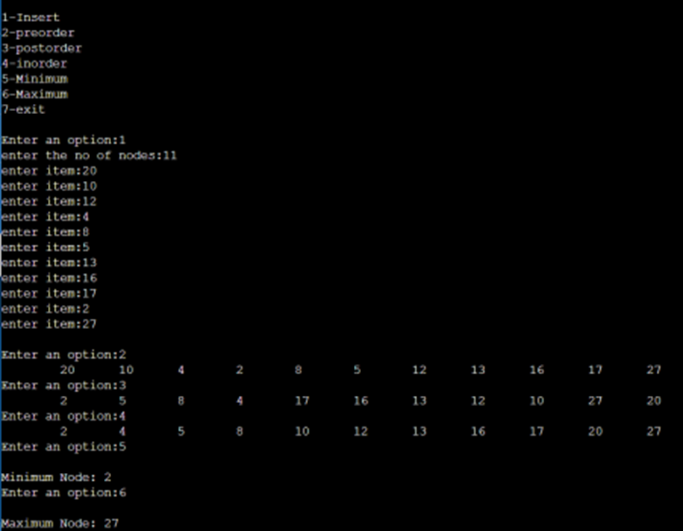

RBT:

#include <stdio.h>

#include <stdlib.h>

enum nodeColor {

RED,

BLACK

};

struct rbNode {

int data, color;

struct rbNode *link[2];

};

struct rbNode *root = NULL;

// Create a red-black tree

struct rbNode *createNode(int data) {

struct rbNode *newnode;

newnode = (struct rbNode *)malloc(sizeof(struct rbNode));

newnode->data = data;

newnode->color = RED;

newnode->link[0] = newnode->link[1] = NULL;

return newnode;

}

// Insert an node

void insertion(int data) {

struct rbNode *stack[98], *ptr, *newnode, *xPtr, *yPtr;

int dir[98], ht = 0, index;

ptr = root;

if (!root) {

root = createNode(data);

return;

}

stack[ht] = root;

dir[ht++] = 0;

while (ptr != NULL) {

if (ptr->data == data) {

printf("Duplicates Not Allowed!!\n");

return;

}

index = (data - ptr->data) > 0 ? 1 : 0;

stack[ht] = ptr;

ptr = ptr->link[index];

dir[ht++] = index;

}

stack[ht - 1]->link[index] = newnode = createNode(data);

while ((ht >= 3) && (stack[ht - 1]->color == RED)) {

if (dir[ht - 2] == 0) {

yPtr = stack[ht - 2]->link[1];

if (yPtr != NULL && yPtr->color == RED) {

stack[ht - 2]->color = RED;

stack[ht - 1]->color = yPtr->color = BLACK;

ht = ht - 2;

} else {

if (dir[ht - 1] == 0) {

yPtr = stack[ht - 1];

} else {

xPtr = stack[ht - 1];

yPtr = xPtr->link[1];

xPtr->link[1] = yPtr->link[0];

yPtr->link[0] = xPtr;

stack[ht - 2]->link[0] = yPtr;

}

xPtr = stack[ht - 2];

xPtr->color = RED;

yPtr->color = BLACK;

xPtr->link[0] = yPtr->link[1];

yPtr->link[1] = xPtr;

if (xPtr == root) {

root = yPtr;

} else {

stack[ht - 3]->link[dir[ht - 3]] = yPtr;

}

break;

}

} else {

yPtr = stack[ht - 2]->link[0];

if ((yPtr != NULL) && (yPtr->color == RED)) {

stack[ht - 2]->color = RED;

stack[ht - 1]->color = yPtr->color = BLACK;

ht = ht - 2;

} else {

if (dir[ht - 1] == 1) {

yPtr = stack[ht - 1];

} else {

xPtr = stack[ht - 1];

yPtr = xPtr->link[0];

xPtr->link[0] = yPtr->link[1];

yPtr->link[1] = xPtr;

stack[ht - 2]->link[1] = yPtr;

}

xPtr = stack[ht - 2];

yPtr->color = BLACK;

xPtr->color = RED;

xPtr->link[1] = yPtr->link[0];

yPtr->link[0] = xPtr;

if (xPtr == root) {

root = yPtr;

} else {

stack[ht - 3]->link[dir[ht - 3]] = yPtr;

}

break;

}

}

}

root->color = BLACK;

}

// Delete a node

void deletion(int data) {

struct rbNode *stack[98], *ptr, *xPtr, *yPtr;

struct rbNode *pPtr, *qPtr, *rPtr;

int dir[98], ht = 0, diff, i;

enum nodeColor color;

if (!root) {

printf("Tree not available\n");

return;

}

ptr = root;

while (ptr != NULL) {

if ((data - ptr->data) == 0)

break;

diff = (data - ptr->data) > 0 ? 1 : 0;

stack[ht] = ptr;

dir[ht++] = diff;

ptr = ptr->link[diff];

}

if (ptr->link[1] == NULL) {

if ((ptr == root) && (ptr->link[0] == NULL)) {

free(ptr);

root = NULL;

} else if (ptr == root) {

root = ptr->link[0];

free(ptr);

} else {

stack[ht - 1]->link[dir[ht - 1]] = ptr->link[0];

}

} else {

xPtr = ptr->link[1];

if (xPtr->link[0] == NULL) {

xPtr->link[0] = ptr->link[0];

color = xPtr->color;

xPtr->color = ptr->color;

ptr->color = color;

if (ptr == root) {

root = xPtr;

} else {

stack[ht - 1]->link[dir[ht - 1]] = xPtr;

}

dir[ht] = 1;

stack[ht++] = xPtr;

} else {

i = ht++;

while (1) {

dir[ht] = 0;

stack[ht++] = xPtr;

yPtr = xPtr->link[0];

if (!yPtr->link[0])

break;

xPtr = yPtr;

}

dir[i] = 1;

stack[i] = yPtr;

if (i > 0)

stack[i - 1]->link[dir[i - 1]] = yPtr;

yPtr->link[0] = ptr->link[0];

xPtr->link[0] = yPtr->link[1];

yPtr->link[1] = ptr->link[1];

if (ptr == root) {

root = yPtr;

}

color = yPtr->color;

yPtr->color = ptr->color;

ptr->color = color;

}

}

if (ht < 1)

return;

if (ptr->color == BLACK) {

while (1) {

pPtr = stack[ht - 1]->link[dir[ht - 1]];

if (pPtr && pPtr->color == RED) {

pPtr->color = BLACK;

break;

}

if (ht < 2)

break;

if (dir[ht - 2] == 0) {

rPtr = stack[ht - 1]->link[1];

if (!rPtr)

break;

if (rPtr->color == RED) {

stack[ht - 1]->color = RED;

rPtr->color = BLACK;

stack[ht - 1]->link[1] = rPtr->link[0];

rPtr->link[0] = stack[ht - 1];

if (stack[ht - 1] == root) {

root = rPtr;

} else {

stack[ht - 2]->link[dir[ht - 2]] = rPtr;

}

dir[ht] = 0;

stack[ht] = stack[ht - 1];

stack[ht - 1] = rPtr;

ht++;

rPtr = stack[ht - 1]->link[1];

}

if ((!rPtr->link[0] || rPtr->link[0]->color == BLACK) &&

(!rPtr->link[1] || rPtr->link[1]->color == BLACK)) {

rPtr->color = RED;

} else {

if (!rPtr->link[1] || rPtr->link[1]->color == BLACK) {

qPtr = rPtr->link[0];

rPtr->color = RED;

qPtr->color = BLACK;

rPtr->link[0] = qPtr->link[1];

qPtr->link[1] = rPtr;

rPtr = stack[ht - 1]->link[1] = qPtr;

}

rPtr->color = stack[ht - 1]->color;

stack[ht - 1]->color = BLACK;

rPtr->link[1]->color = BLACK;

stack[ht - 1]->link[1] = rPtr->link[0];

rPtr->link[0] = stack[ht - 1];

if (stack[ht - 1] == root) {

root = rPtr;

} else {

stack[ht - 2]->link[dir[ht - 2]] = rPtr;

}

break;

}

} else {

rPtr = stack[ht - 1]->link[0];

if (!rPtr)

break;

if (rPtr->color == RED) {

stack[ht - 1]->color = RED;

rPtr->color = BLACK;

stack[ht - 1]->link[0] = rPtr->link[1];

rPtr->link[1] = stack[ht - 1];

if (stack[ht - 1] == root) {

root = rPtr;

} else {

stack[ht - 2]->link[dir[ht - 2]] = rPtr;

}

dir[ht] = 1;

stack[ht] = stack[ht - 1];

stack[ht - 1] = rPtr;

ht++;

rPtr = stack[ht - 1]->link[0];

}

if ((!rPtr->link[0] || rPtr->link[0]->color == BLACK) &&

(!rPtr->link[1] || rPtr->link[1]->color == BLACK)) {

rPtr->color = RED;

} else {

if (!rPtr->link[0] || rPtr->link[0]->color == BLACK) {

qPtr = rPtr->link[1];

rPtr->color = RED;

qPtr->color = BLACK;

rPtr->link[1] = qPtr->link[0];

qPtr->link[0] = rPtr;

rPtr = stack[ht - 1]->link[0] = qPtr;

}

rPtr->color = stack[ht - 1]->color;

stack[ht - 1]->color = BLACK;

rPtr->link[0]->color = BLACK;

stack[ht - 1]->link[0] = rPtr->link[1];

rPtr->link[1] = stack[ht - 1];

if (stack[ht - 1] == root) {

root = rPtr;

} else {

stack[ht - 2]->link[dir[ht - 2]] = rPtr;

}

break;

}

}

ht--;

}

}

}

// Print the inorder traversal of the tree

void inorderTraversal(struct rbNode *node) {

if (node) {

inorderTraversal(node->link[0]);

printf("%d ", node->data);

inorderTraversal(node->link[1]);

}

return;

}

int main() {

int ch, data;

while (1) {

printf("1. Insertion\t2. Deletion\n");

printf("3. Traverse\t4. Exit");

printf("\nEnter your choice:");

scanf("%d", &ch);

switch (ch) {

case 1:

printf("Enter the element to insert:");

scanf("%d", &data);

insertion(data);

break;

case 2:

printf("Enter the element to delete:");

scanf("%d", &data);

deletion(data);

break;

case 3:

inorderTraversal(root);

printf("\n");

break;

case 4:

exit(0);

default:

printf("Not available\n");

break;

}

printf("\n");

}

return 0;

}

Output:

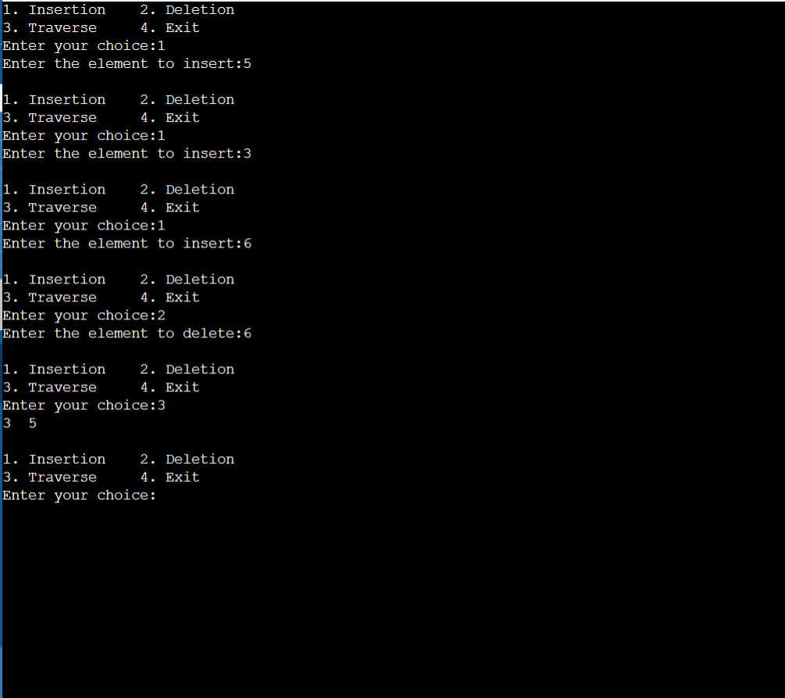

B Tree:

#include <stdio.h>

#include <stdlib.h>

#define MAX 3

#define MIN 2

struct BTreeNode

{

int val[MAX + 1], count;

struct BTreeNode *link[MAX + 1];

};

struct BTreeNode *root;

struct BTreeNode *createNode(int val, struct BTreeNode *child) { struct BTreeNode *newNode;

newNode = (struct BTreeNode *)malloc(sizeof(struct BTreeNode)); newNode->val[1] = val;

newNode->count = 1;

newNode->link[0] = root;

newNode->link[1] = child;

return newNode;

}

void insertNode(int val, int pos, struct BTreeNode *node, struct BTreeNode *child) {

int j = node->count;

while (j > pos) {

node->val[j + 1] = node->val[j];

node->link[j + 1] = node->link[j];

j--;

}

node->val[j + 1] = val;

node->link[j + 1] = child;

node->count++;

}

void splitNode(int val, int *pval, int pos, struct BTreeNode *node, struct BTreeNode *child, struct BTreeNode **newNode) { int median, j;

if (pos > MIN)

median = MIN + 1;

else

median = MIN;

*newNode = (struct BTreeNode *)malloc(sizeof(struct BTreeNode)); j = median + 1;

while (j <= MAX) {

(*newNode)->val[j - median] = node->val[j];

(*newNode)->link[j - median] = node->link[j];

j++;

}

node->count = median;

(*newNode)->count = MAX - median;

if (pos <= MIN) {

insertNode(val, pos, node, child);

} else {

insertNode(val, pos - median, *newNode, child);

}

*pval = node->val[node->count];

(*newNode)->link[0] = node->link[node->count];

node->count--;

}

int setValue(int val, int *pval,

struct BTreeNode *node, struct BTreeNode **child) { int pos;

if (!node) {

*pval = val;

*child = NULL;

return 1;

}

if (val < node->val[1]) {

pos = 0;

} else {

for (pos = node->count;

(val < node->val[pos] && pos > 1); pos--)

;

if (val == node->val[pos]) {

printf("Duplicates are not permitted\n");

return 0;

}

}

if (setValue(val, pval, node->link[pos], child)) {

if (node->count < MAX) {

insertNode(*pval, pos, node, *child);

} else {

splitNode(*pval, pval, pos, node, *child, child); return 1;

}

}

return 0;

}

void insert(int val) {

int flag, i;

struct BTreeNode *child;

flag = setValue(val, &i, root, &child);

if (flag)

root = createNode(i, child);

}

void search(int val, int *pos, struct BTreeNode *myNode) { if (!myNode) {

return;

}

if (val < myNode->val[1]) {

*pos = 0;

} else {

for (*pos = myNode->count;

(val < myNode->val[*pos] && *pos > 1); (*pos)--) ;

if (val == myNode->val[*pos]) {

printf("%d is found", val);

return;

}

}

search(val, pos, myNode->link[*pos]);

return;

}

void traversal(struct BTreeNode *myNode) { int i;

if (myNode) {

for (i = 0; i < myNode->count; i++) {

traversal(myNode->link[i]);

printf("%d ", myNode->val[i + 1]);

}

traversal(myNode->link[i]);

}

}

int main() {

int val, ch;

insert(8);

insert(9);

insert(10);

insert(11);

insert(15);

insert(16);

insert(17);

insert(18);

insert(20);

insert(23);

traversal(root);

printf("\n");

search(11, &ch, root); }

output:

